# PRACTICAL 20: Use Case and DFDs

Tutor Guide

**Tutor Led Exercise 1 - Faulty Diagrams**

What is wrong with each of the following diagrams?

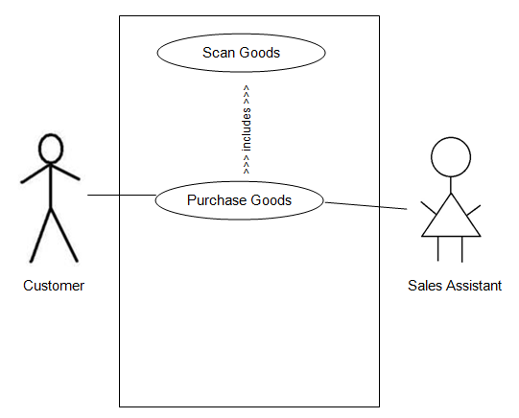

A sales assistant doesn’t purchase goods, instead there should be a separate function for authorisation of a sale. There are also other things that a sale assistant can do such as look up items. The boundary also doesn’t have a name, each system should be named so that we know what the system is about. The link to scans goods is also incorrect.

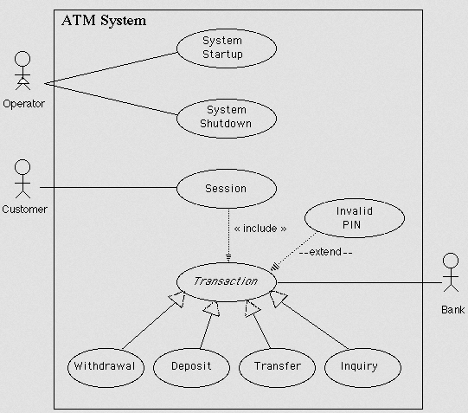

The arrows for withdrawal, deposit, transfer and inquiry are incorrect, these should be extend.

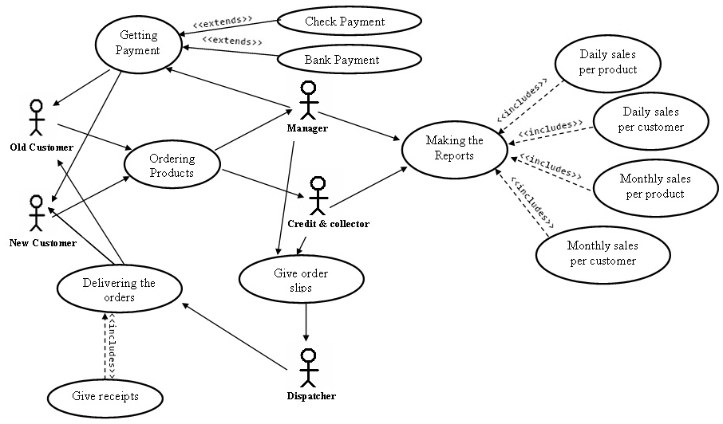

This is not organised well, making it difficult to understand. Putting all the functions in a boundary makes it more organised and the stakeholders should be on the outside.

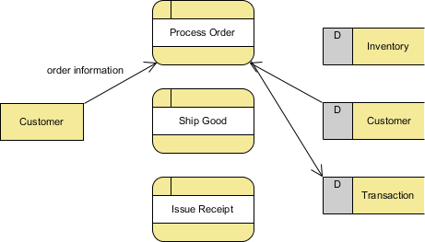

Some processes and data stores aren’t linked to the system. No labels or numbering for the processes or the data stores. No labels for arrows on the right.

**Tutor Led Exercise 2 - Answers to last weeks exercises**

Exercise 1

|  |  |
| --- | --- |
| **Actors** | **Use-Case** |
| Students  Staff |  |

Exercise 2

|  |  |  |
| --- | --- | --- |
| **Actors** | **Use-Case** | **Includes** |
| Customers  Staff |  | Reciept |

**Student Exercise - Coursework Submission 3**

With any remaining time, work on your coursework. Make sure you ask for tutor help and get your draft work reviewed